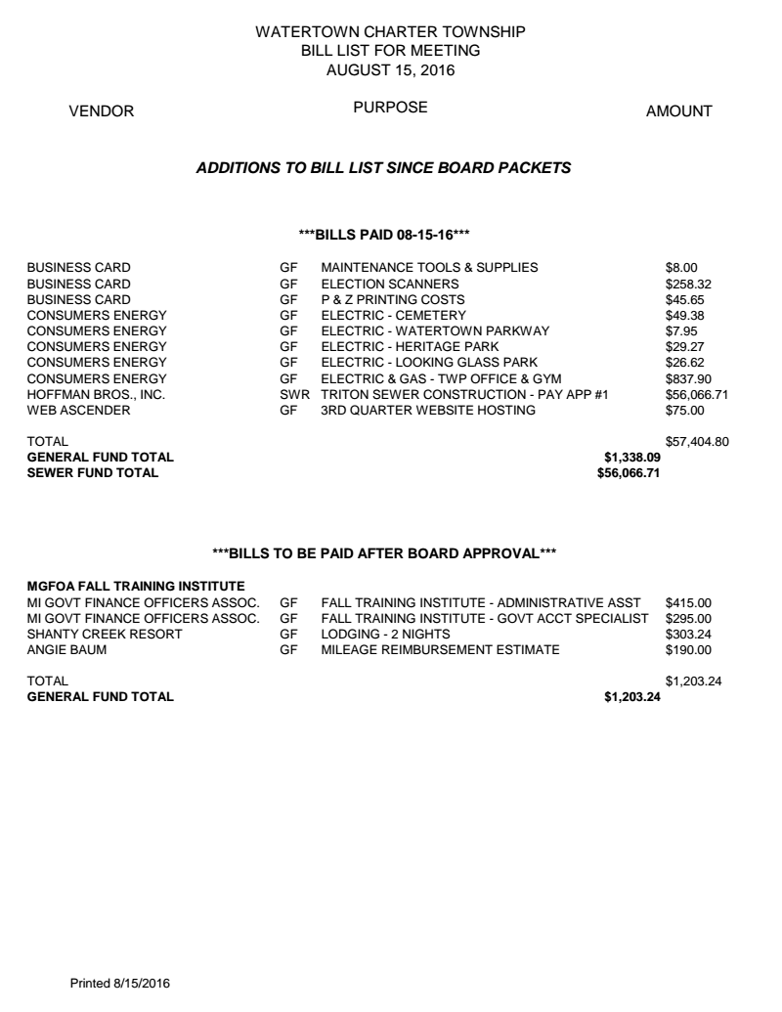

9-9-16: Email to Watertown Township Board Members:
This is a copy of the extra bill list on the table for the 8-15-16 Board of Trustees regular meeting. The bill of electric and gas for the Township Hall and Gym for the month of August 2016 was $837.90. I did some research to determine the reason for the high energy costs. I discovered the air conditioning units for the Township Hall and Gym were running nights and weekends. I can only assume they ran 24/7, 7 days a week in order to use that much energy.
It is my opinion that this is not good management of our tax dollars and is not even questioned by our elected officials when approving the bill list!!
Dale Westrick
9041 W Herbison
Grand Ledge MI 48837
Email dale.r.westrick@gmail.com
Phone 517-626-2256
Website www.wacousta.org
Date 9-10-16

Please place in correspondence for the 9-18-16 Board packet!!

